LAB 3:

OSCILLOSCOPE

Class: EEE 117 Lab

Professor: Sergio Aguilar Rudametkin

Author: Ramyasri Singamsetty

October 10, 2018

* 1. **INTRODUCTION**

This lab focuses on using one of the main lab equipment called an oscilloscope. The oscilloscope is an instrument that measures displays voltage signals as waveforms to a digital screen. The focus of this lab is to learn how to use an oscilloscope, given certain specifications and adjustments. From these adjustments, we also performed calculations that helped us to find other measurements.

* 1. **PURPOSE**

The purpose of this lab is to learn and understand how to use the oscilloscope in relation to general measurements that correspond to different settings on the instrument. The three main functions we are working with include measuring using vertical controls, triggering controls, and finally reading general measurements. After recording measurements for the first section ,we were asked to calculate the missing resistance in a circuit by using circuit analysis applications. The resistance value calculated from this section, was then used to complete the next two sections.

* 1. **PROCEDURE**

**Part I. Vertical Controls**

For this portion of the lab we worked with the vertical control section of the oscilloscope. The vertical control section of the oscilloscope deals with moving the waveforms displayed to the screen up and down, or in a vertical motion. This part of the lab mainly deals with measuring the voltage using the oscilloscope and specifically the peak to peak voltage in relation to the calibrator. We measured the calibrated voltage in terms of two different settings: X1 and X10.

|  |  |  |
| --- | --- | --- |
|  | X1 | X10 |
| Calibrator Voltage | 24V | 2.4 X 10 = 24 V |

We then recorded the observations of the trace on the oscilloscope after adjusting the time base control for about 4 cycles of the sine wave. Our observation was that the trace is a square wave and when we turn the vertical controls to the right, the time scale decreases (in the horizontal section) meaning that less cycles appeared on the screen. This was also true for the opposite functions. When the vertical controls were turned, the voltage increases which can be seen by the rise in peak value.

We recorded the observations of the trace on the oscilloscope after adding a DC offset of 1 volt on the function generator. We observed that this shifts the trace up in a vertical manner in the positive y-direction.

We also recorded observations of the oscilloscope when the channel coupling is changed from DC to AC. In this case, we observed that the trace goes “faster” and could only be stabilized by reducing the trigger level to 0.0 volts and would become unstable when changed to around 144 volts. (Channel # 1).

The circuit below was used to make further measurements on the oscilloscope. In the given circuit, we had to find the missing resistance value by by using the given Vin, Vout, resistance, and capacitance and by using circuit analysis.

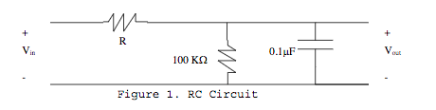

We found our R value to be 1617.29 Ohms(calculation shown in Pre-lab). After finding our missing resistance value, we built the given circuit. This section simply worked with moving the trace on the screen in a vertical position in Channel # 2 until the trace was completely off the screen. This portion of the lab gave us experience with simple vertical control movements on the oscilloscope.

**Part II. Triggering Controls**

This portion of the lab requires observations on how triggering controls on the oscilloscope change in accordance to different settings. We first observed how the triggering point changes as the trigger level changes. We noted that the trace shifts to the right when the triggering controls are turned down and shifts left when the triggering controls are shifted up.

We then selected “SLOPE/COUPLING” and then from the on-screen menu we selected “+/-“ (arrow up or down).We had to observe what happens to the triggering point as the slope is toggled from + to -. We observed that the rising slope (+) is lagging the falling slope (-) which results in a negative phase shift.

We then observed what happens when the triggering mode is toggled from the “AUTO” to the “NORM” setting. In terms of triggering levels that were within the same signal voltage, we observed that the trace stays the same and that it is stable. In terms of triggering levels outside of the signal voltage range, we observed that there is a unstable signal add this applies to both channel # 1 and channel # 2.

**Part III. Measurements**

This portion of the lab deals with measuring the AC (RMS) values using the Digital Multimeter. We set the function generator to have a peak to peak voltage value of 1 in a sine wave with a 0 volt offset. We then connected the function generator to the Digital Multimeter and to channel # 2 of the oscilloscope. We measured the AC(RMS) value by selecting voltage on the oscilloscope and found that the AC(RMS) value to be 0.70613 Volts AC. On the oscilloscope we found the AC RMS to be 715.5 mV or 0.715 volts. Both the readings on the DMM and the oscilloscope are close to each other and can be considered consistent.

Next, we connected a 51 Ohm resistor across the function generator and took the same exact readings. We measured the AC(RMS) value on the oscilloscope to be 334.75 mV(0.334 Volts) and th AC(RMS) value on the DMM to be 0.331 VAC. So the readings here are also consistent. The function generator is set to the perfect voltage when both the measured values of the AC(RMS) on the DMM and the oscilloscope match.

Finally, we used the RC circuit built in Part I to measure the RMS voltages of both waveforms. This time, we used the FREQUENCY setting on the oscilloscope in order to measure the frequency of the waveforms. After measuring the frequency, we changed the setting to measure the TIME, which essentially measured the period of the waveforms along with the time delay.

|  |  |  |  |
| --- | --- | --- | --- |
|  | RMS | Frequency | Time |
| WAVEFORM 1 | 6.97 V | 0.999 KHz | 1.00 ms |
| WAVEFORM 2 | 4.87 V | 0.999KHz | 1.00 ms |

Phaseshift = 360 * time delay/period

360 * 120.05 uS/1 = 43,218

**Discussion Topics**

1. When the coupling was changed from DC to AC in Part I, the trace appeared to be going faster and could only be stabilized by reducing the trigger level to 0 volts. DC coupling represents a direct current while AC coupling deals with alternating current and can affect how the trace looks in the vertical channel.
2. Sketch of the input/output waveforms in Part I: They appear to be 45 degrees apart.

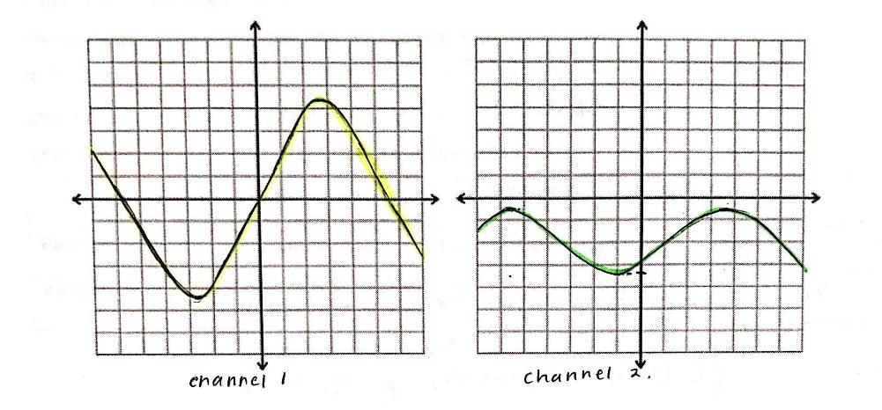

1. The X1 and X10 probes on the oscilloscope represent how much resistance is being applied to the current measurements. X1 represents a weaker resistance than the X10 probe does, and the X10 probe is more effective.
2. When the triggering level was changed from + to - , we observed that the rising slope (+) is lagging the falling slope (-) which results in a negative phase shift.
3. We then observed what happens when the triggering mode is toggled from the “AUTO” to the “NORM” setting. In terms of triggering levels that were within the same signal voltage, we observed that the trace stays the same and that it is stable. In terms of triggering levels outside of the signal voltage range, we observed that there is a unstable signal add this applies to both channel # 1 and channel # 2.
4. The significance of the 51 Ohm output resistance of the function generator simply allows us to work with a resistance value applied to the given measurements and helps us to take measurements with a resistance involved.
5. The measured and calculated magnitudes and phase shift of the RC circuit match as the values are very close to each other.

**Conclusion**

The overall lessons that we learned from this lab consist of learning and working with how to use an oscilloscope to take measurements of simple elements of a circuit to larger more complicated circuits. The oscilloscope has multiple settings and we specifically worked with the vertical and triggering controls and took measurements independent and dependent of the function generator. This lab is essential because the oscilloscope is an instrument that is used widely in the engineering field, and is important to know and learn how to use.

I found that the hand calculations for this lab to be quite challenging but beneficial because it helped me to understand how to calculate resistance and phase shift values and compare these values to the measured ones. This lab was very tedious but very helpful because working with an oscilloscope allows you to take measurements faster and in different modes and settings.